

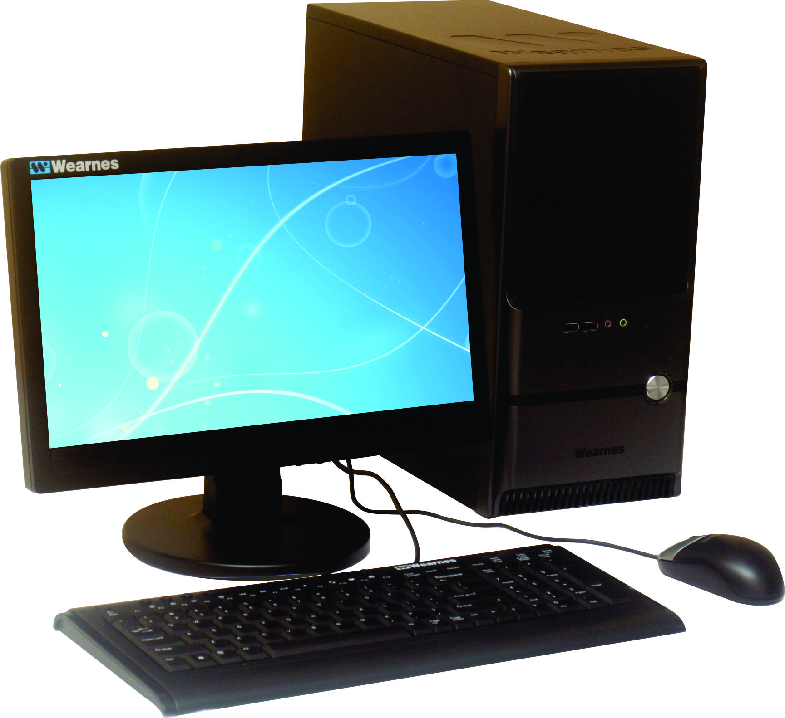
Specifications
Processor | Supports Intel® Sandy Bridge processors in LGA1155 package.
Chipset | Intel® H61 (B3) Chipset
System Memory | Supports two DDR3 1066/1333 DRAM, 16GB Max  Supports Dual channel mode
Video | Integrated Intel® HD Graphics, DVMT up to 731MB
Audio | Integrated HD Audio
LAN | Integrated 10/100/1000 Mb/s (Gb) LAN
Hard Disk | Support SATAII HDD
Optical Drive | Optional
Expansion Slots | • 1 x PCI Express Gen2 x16 slot  • 3 x PCI Express Gen2 x1 slots
I/O Interface | Rear :  • 1 x PS/2 Mouse port  • 1 x PS/2 Keyboard port  • 4 x USB 2.0 ports  • 1 x Parallel port  • 1 x Serial port  • 1 x Graphics Card port  • 1 x RJ45 LAN Jack  • 1 x 3 in 1 audio jack | Front :  • 2 x USB 2.0 ports  • 2 x Audio jacks for headphone  and microphone
Chassis | Micro Tower ATX
Keyboard & Mouse | Wearnes Keyboard & Wearnes Optical Mouse
Power Supply | 300 Watt
Monitor | Wearnes 15" LCD Monitor (Optional)
 | * Specifications are subject to change without prior notice

Premiere 8610L

Product Information
Wearnes Premiere Series
www.wearnespc.com

